Privacy Compliance Documentation

Overview

This document is meant to provide an overview of what it means to be in compliance with various email marketing anti-spam laws, specifically the Canada Anti-Spam Law (CASL) and General Data Protection Regulation (EU) and capture what system processes implemented using Etumos architecture to meet compliance. The following summaries of the respective laws are just that - summaries. They should not be taken for the law. Any business processes defined should not be only reliant on the information below.

The following recommendations and implementation deal solely with emails, a subset of the overall Privacy Compliance requirements. This program does not deal with cookies, data storage, data partnership agreements, or non-email-sending subsets of GDPR.

Summary of Policy Decisions

CASL

- Forms presented to people in Canada should present the Explicit Consent checkbox, defaulted to being unchecked.
- People checking the box are considered opted-in
- Customers can be Marketed to unless they unsubscribe
- Ex-customers can be Marketed to unless they unsubscribe, for a period of time. The current logic is for 2 years.
- Certain engagement activity, called “Inquiry” can be implied as consent to Market. This also has an expiration without further activity. The current assumption is 6 months. Inquiry is defined at the moment as: Filling out a demo request form, logging of an activity starting with “Intercom Chat” or the Intercom Conversation User Create transcript not being empty.

GDPR

- Forms presented to people in GDPR countries (EU) should present the Explicit Consent checkbox, defaulted to being un-checked.
- In addition, Austria and Germany require double opt-in. In our implementation, this is done when we receive an explicit opt-in on a form from someone in German or Austria. An email is sent linking to a landing page. If someone clicks through and visits the page they will be considered double opted-in. A status that will persist unless someone unsubscribes.
- Although the GDPR laws do not consider exemptions for customers, for this implementation we do.
- Ex-customers are also included in the allowable group in this implementation with an expiration of 1 year.

Canada Anti-Spam Law (CASL)

What is CASL?

CASL went into effect on July 1, 2014 to restrict how commercial electronic messages (CEMs) are sent to subscribers in Canada. A three year transition period followed the legal start date, requiring companies to be in full compliance by July 1, 2017. The law enforces companies sending CEMs to subscribers in Canada to gain consent. The restrictions around when CEMs can be sent to subscribers varies based on the type of consent obtained (expressed or implied) and the type of subscriber being sent CEMs.

Expressed consent

If the subscriber takes an action to give permission to send CEMs to him/her, then expressed consent has been obtained. A few things to note about expressed consent:

- Party asking for expressed consent needs to clearly state they are seeking expressed consent for CEMs
- Pre-checked boxes and/or auto-filled email addresses do not qualify as expressed consent
- Notice of ability to unsubscribe must be clear and visible in all future email communications
- Terms and conditions for consent, if currently bundled with promotional terms and conditions, must be unbundled.

Implied consent

If the subscriber and party seeking consent have an existing business relationship (defined by having engaged in a transaction, contract or barter) within the last 2 years OR an individual has conspicuously disclosed their email address to the sender (via business card or electronically via inquiry) then the sender has gained implied consent. One item to note with implied consent:

- Notice of ability to unsubscribe must be clear and visible in all future email communications

Sending CEMs - Expressed Consent

Expressed consent prior to July 1, 2014
If expressed consent was received prior to July 1, 2014 then the expressed consent carries forward.

Expressed consent after July 1, 2014
Expressed consent obtained after July 1, 2014 will carry forward until the subscriber withdraws subscription via opt-out, unsubscribe link, or subscription center.

Sending CEMs - Implied Consent

Implied consent prior to July 1, 2014
If implied consent was received prior to July 1, 2014 then implied consent carries forward for the full 3 year transition period as long as the subscribers were being sent CEMs prior to July 1, 2014. However, the sending party must reconfirm consent with subscriber by July 1, 2017. Date stamps of email received are required to prove implied consent prior to July 1, 2014.

Implied consent after July 1, 2014
Sending parties have 2 years from the date of expiration of the contract to continue to send CEMs to former customers. Sending parties have 6 months from the last known inquiry date to send to all other implied consenting subscribers.

Exceptions

Consent is not required when the sending party is delivering a CEM that contain any of the following:

- Quotes or estimates
- Confirmation of a transaction
- Recalls, safety/security information and or warranty information
- Information relating to ongoing purchases, subscription(s), membership(s), accounts, loans, employment relationships or benefit plans
- Product or services updates or upgrades

Finally, CASL treats the following circumstances in a different manner:

- CEMs being sent with the sole purpose to raise funds for a registered charity are exempt from CASL.

- CEMs being sent to a subscriber by way of referral do not require consent, but the referrer name(s) must be included in the CEM.

- A business partner of a sending party may supply subscriber information to that company, but the CEM must include the name of the company that supplied the subscriber information where collected permission may not be the sender. Updates to a subscriber’s email preferences must be made known to all partners who received subscriber information.

General Data Protection Regulation - EU (GDPR)

What is GDPR?

GDPR was approved and April 14, 2016 to regulate data privacy laws across EU countries. A two year transition rule follows, requiring companies to be in full compliance by May 28, 2018. The law requires companies obtain explicit opt-in from any citizens or persons residing in any EU country before using their data (their contact information, etc.).

Expressed consent

GDPR is fairly straight forward in requiring an explicit opt-in for using data for individuals in the EU, which would include using email addresses for sending email communications. No other consent will qualify (i.e. implied).

Compliance within Marketo
The Etumos privacy policy program supplies the framework for tracking and maintaining consent with respect to GDPR and CASL. Proper unsubscribe and terms & conditions, privacy policy, a paper trail for how data is obtained associated with GDPR and CASL are not covered with the Etumos privacy program and are out of scope.

Retroactive Assignment

Depending on the current state of the privacy policy program(s) already in place and the date which the existing privacy policy program(s) took action, retroactive assignment of subscribers in Canada and the EU may be necessary.

This section is intended to document the policies put into place in the Intercom instance using the Etumos architecture.

CASL Assumptions
- Compliance groupings are: Explicit, Implied Consent - Customer, Implied Consent - Ex-Customer, Implied Consent - Inquiry, No Consent
- Consent Expiration for Implied Consent (ex-customer & inquiry) = 180 Days

GDPR
- Compliance groupings are: Explicit, Implied Consent - Customer, Implied Consent - Ex-Customer, No Consent
- Consent Expiration for Ex-Customer = 2 years
- Double Opt-In countries = Germany & Austria

Other countries
- Countries known but not covered by CASL or GDPR are set to process through CANSPAM
- The logic is simply to add them to a list, no changes are made to their database record

Unknown Countries
- Represented by the “Default” segment within the Privacy/Compliance segmentation
- These process through the GDPR process. Because we do not know their location we need to apply a fairly strict policy to keep risk low.

Custom Field Creation

Three custom fields will be necessary to implement and streamline the Etumos privacy policy program. All three fields need to be created in SFDC on the lead and the contact.

- “Explicit Opt-In” (boolean field) [Explicit Consent]
- “Explicit Opt-In Date” (date field)
- “Consent Expiration” (date field)
- “Double Opt-In” (boolean) Suggested
- “Double Opt-In Date” (date field) Suggested
- “Double Opt-In Description” (string field) Suggested

Program Overview

The Etumos privacy policy program will be a mixture of requestable and triggered smart campaigns that will manage explicit and implied opt-in status, and expiration of implied opt-in status. This program relies on the marketing suspend functionality in Marketo. A full demo of the program architecture will follow the completion of this worksheet.

Triggers and Sorting

This first section of the framework is responsible for entry into the program and sorting into the appropriate policy.

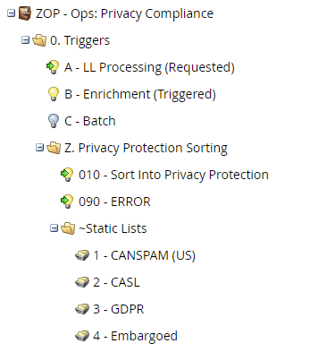
Initial sorting is either requested by the Lifecycle Processing (for new entrants to the database) or triggered by attributes changing that could affect what policy a person belongs to.

The policy that applies is determined by segment membership in the Privacy Compliance segmentation.

CANSPAM (US)

This policy is the most relaxed without anything to manage at the database level other than noting that someone has been processed into this policy. The rules of the CANSPAM law apply to the content of the email, requiring a physical address, company name and the ability to unsubscribe. Unsubscribe functionality is a default behavior in Marketo with a system token that will provide the correct link if it is desired.

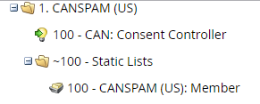

CASL

As previously mentioned, CASL has several rules and policies that allow for email communication and the framework here is configurable with specific legal interpretations of each.

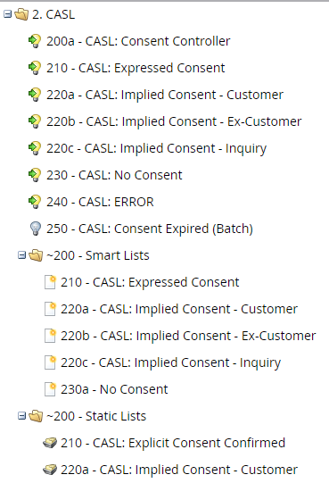

The Smart Campaign “250 - CASL: Consent Expired (Batch)” processes those people with a time-based permission that are at the end of the permission period, indicated by the Consent Expiration field.

GDPR

Intercom’s interpretation of GDPR will allow for Customer and Ex-Customer Implied/implicit consent.

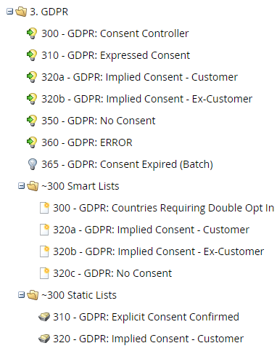

Embargoed Countries (EMB)

Here we sort people from countries we cannot do business with according to government restrictions. The people that sort here are unsubscribed and logged to a list.

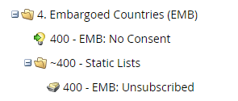

Double Opt-In

This functionality is provided in its own area to allow for a flexible policy. While generally only used for Germany and Austria some clients choose to apply it more broadly.

The basic flow here is a one or two email cadence with a day or two in between. After the challenge email is sent the person is most often sent through the “No Consent” option that applies to them, which unsubscribes them with a reason indicative of the need for double opt-in.

A campaign listening for response to the challenge email will re-subscribe any respondents and clear the reason, checking the Double Opt-In field to TRUE.

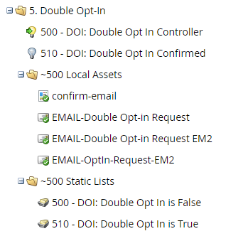

Data Retention / Withdrawal of Consent

If your Legal team has determined that there are groups of people in the database that should be removed or archived due to their lack of consent or deliberate withdrawal of consent, this section of the framework has been provided to support that effort.

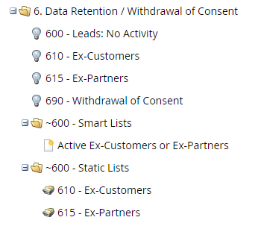

Appendix

Privacy Compliance Segmentation

The following section outlines the rules for determining which segment a person belongs to.

CAN
Country = United States or United States of American OR
(Country is Empty AND Inferred Country = United States)

CASL

Country = Canada OR
(Country is Empty AND Inferred Country = Canada)

GDPR

Logic as prior groups, apply using the following countries:
Aland Islands, Austria, Belgium, Bulgaria, Croatia, Cyprus, Czech Republic, Czechia, Denmark, Estonia, Europe, Finland, France, Germany, Great Britain, Greece, Hungary, Ireland, Italy, Latvia, Lithuania, Luxembourg, Malta, Netherlands, Poland, Portugal, Romania, Slovak, Republic, Slovakia, Slovenia, Spain, Sweden, The Netherlands, United Kingdom

Embargoed

Logic as in prior groups, applied to the following countries:
Cuba, Iran, North Korea, Sudan, Syria, Ukraine, Syrian Arab Republic, Democratic People's Republic of Korea, Iran, Islamic Republic of

Other

Logic as in prior groups, applied to people that have either a country or inferred country that is none of the above.

Default

This should be anyone whose country can not be determined.

Sources

The information contained in this worksheet came from review of the following sources:
http://thedma.org/wp-content/uploads/CASL_guidance.pdf
https://knowledgebase.constantcontact.com/articles/KnowledgeBase/5924-implied-and-express-permission-in-casl-regulations
http://laws-lois.justice.gc.ca/eng/acts/E-1.6/page-3.html#docCont
http://kb.mailchimp.com/accounts/compliance-tips/about-the-canada-anti-spam-law-casl
https://www.salesfusion.com/resource/a-marketers-guide-to-the-new-gdpr-regulations/
http://www.eugdpr.org/

